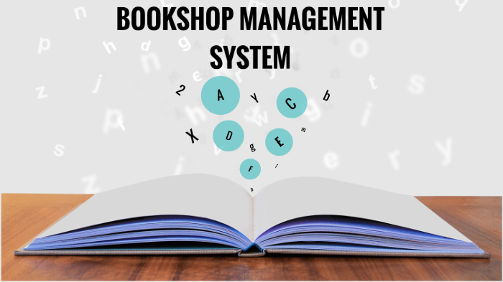

**DEPARTMENT OF COMPUTER SCIENCE**

PROJECT PROPOSAL

SUBMITTED TO: SIR HASHIM AYUB

**PROJECT PROPOSAL**

**TOPIC:**

BOOKSTORE MANAGEMENT SYSTEM

**GROUP MEMBERS:**

* **NAME:** Mobeen Saeed Mughal

**REG NO:** BCS213072

* **NAME:** Ruquiya Nasir

**REG NO:** BCS213065

* **NAME:** Laiba Shahzadi

**REG NO:** BCS213053

**ABSTRACT:**

Here we are going to develop a book store management system in which customer can select Category of books, can view list of books of selected category, can Order book and check the price, can pay for book, can Cancel order.

This Bookshop Management System Project in C with Source Code is a project created only for the purpose of meeting educational requirements

The bookstore management system helps to keep track of all the book records in a file.

THE END☺